BLK16E-0235P-38X38-B V1.01 Interface Description
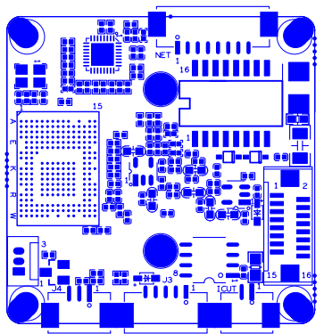
P1 Power Ethernet
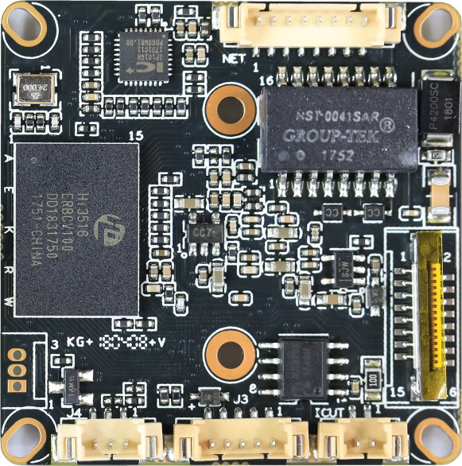
P6 Extension
P3 IRcut
P2 Infrared
P6 Alarm Audio

sign | Socket | Specific No | Interface Description | Function
P1 | J3 | 1 | LED/PHY_AD0 | LED
P1 | J3 | 2 | LED/PHY_AD1 | LED
P1 | J3 | 3 | ETHTX+ | Ethernet signal
P1 | J3 | 4 | ETHTX- | Ethernet signal
P1 | J3 | 5 | ETHRX+ | Ethernet signal
P1 | J3 | 6 | ETHRX- | Ethernet signal
P1 | J3 | 7 | GND | GND
P1 | J3 | 8 | 12V | 12V DC input
P2 | J4 | 1 | Infrared input | Infrared input
P2 | J4 | 2 | GND | GND
P2 | J4 | 3 | +3.3V | 3.3V DC input
P3 | J5 | 1 | BOUT | IRCUT output
P3 | J5 | 2 | AOUT | IRCUT output
P5 | J2 | 1 | UART_RX
P5 | J2 | 2 | UART_TX
P5 | J2 | 3 | GND | GND
P6 | J3 | 1 | AC_OUT | AC_OUT
P6 | J3 | 2 | AC_IN | MIC_P
P6 | J3 | 3 | GND | GND
P6 | J3 | 4 | ALARM_GPIO | ALARM_IN
P6 | J3 | 5 | GND | GND

P7 | J19 | 1 | SD_CLK | SD_CLK
P7 | J19 | 2 | SD_CMD | SD_CMD
P7 | J19 | 3 | SD_DATA0 | SD_DATA0
P7 | J19 | 4 | SD_DATA1 | SD_DATA1
P7 | J19 | 5 | SD_DATA2 | SD_DATA2
P7 | J19 | 6 | SD_DATA3 | SD_DATA3
P7 | J19 | 7 | ALARM2_GPIO82 | ALARM2_GPIO82
P7 | J19 | 8 | GND | GND
P7 | J19 | 9 | KEY_SET | KEY_SET
P7 | J19 | 10 | BAT | BAT
P7 | J19 | 11 | GND | GND
P7 | J19 | 12 | ALARM_OUT | ALARM_OUT
P7 | J19 | 13 | USB_DM | USB_DM
P7 | J19 | 14 | USB_DP | USB_DP
P7 | J19 | 15 | +5V | +5V
P7 | J19 | 16 | USB_CONTROL | USB_CONTROL

