Interfacedescription：
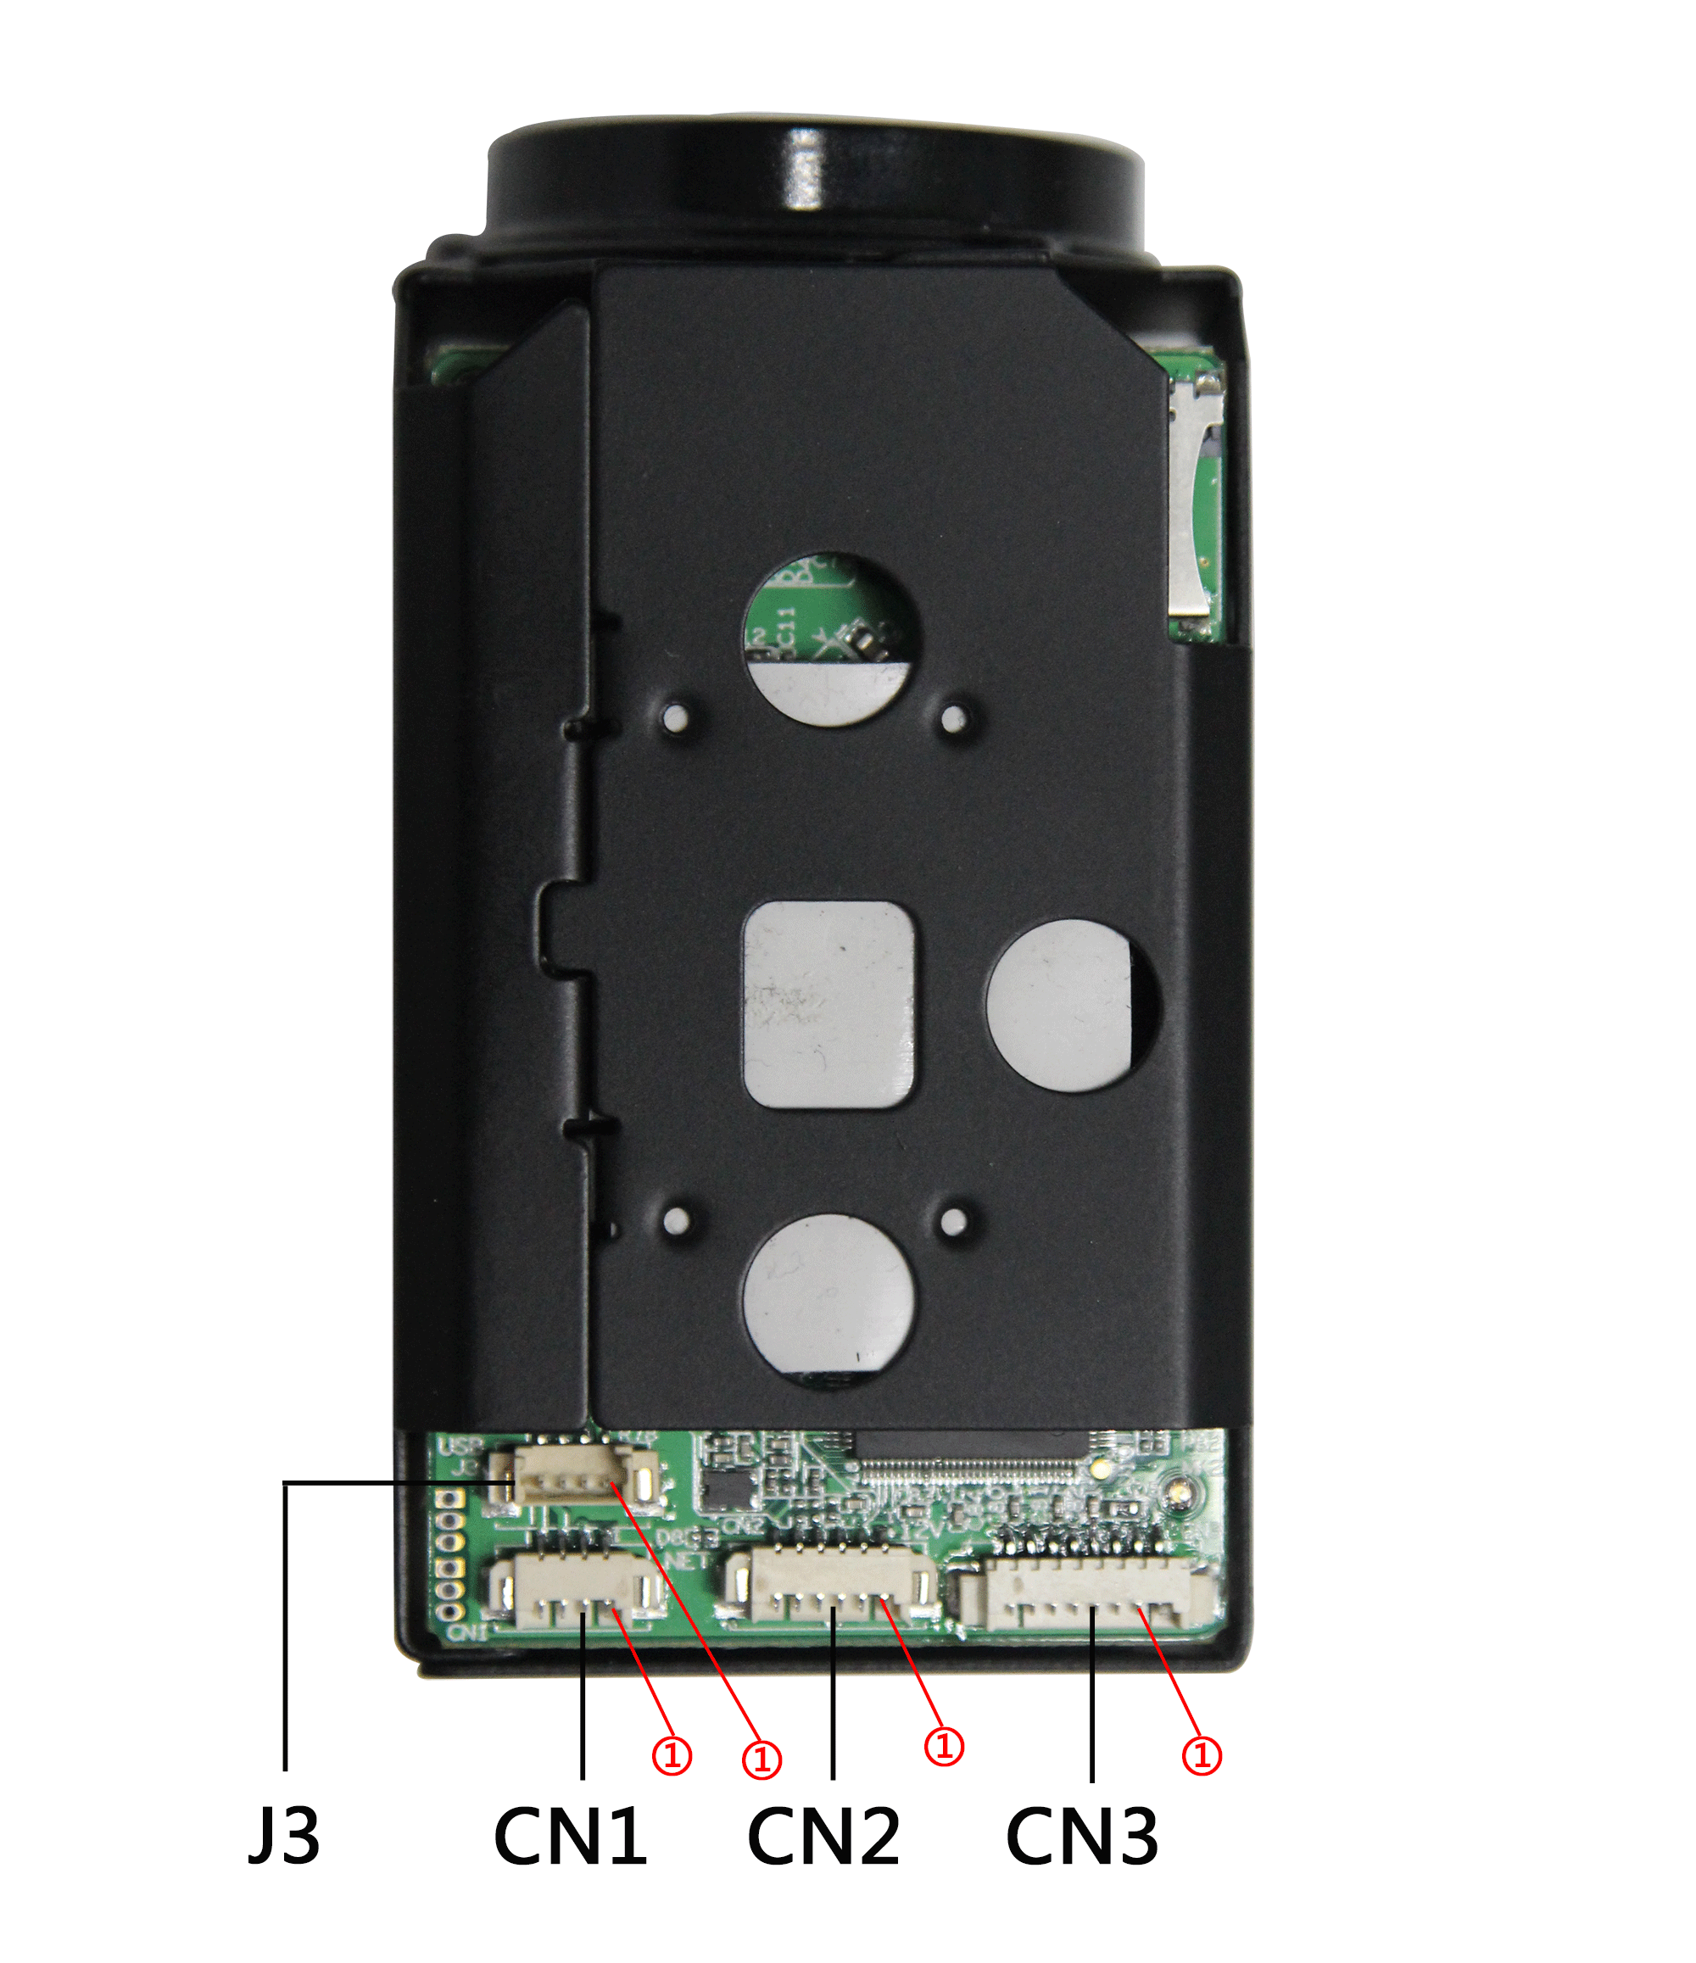

sign | Socket | Specific No |  |  | Interface Description
CN1 | 1 |  | ETHRX- |  | Ethernet receiver negative pole
CN1 | 2 |  | ETHRX+ |  | Ethernet receiver positive pole
CN1 | 3 |  | ETHTX- |  | Ethernet transmitter negative pole
CN1 | 4 |  | ETHTX+ |  | Ethernet transmitter
CN2 | 1 |  | 12V |  | DC+9V ~ +12V
CN2 | 2 |  | GND |  | GND
CN2 | 3 |  | RXD | UART | TTL，485：PELCOD,PELCOP
CN2 | 4 |  | TXD | UART | TTL，485：PELCOD,PELCOP
CN2 | 5 |  | RXD | UART | Control serial port，VISICA，baud rate 9600bps
CN2 | 6 |  | TXD | UART | Control serial port，VISICA，baud rate 9600bps
CN3 | 1 |  | GND |  | GND
CN3 | 2 |  | CVBS_OUT |  | CVBS_OUT
CN3 | 3 |  | AGND |  | AUDIO GND
CN3 | 4 |  | AO_OUT |  | AUDIO OUTPUT
CN3 | 5 |  | AI_LINE |  | AUDIO INTPUT
CN3 | 6 |  | ALARM_IN1 |  | ALARM_IN1
 | 7 |  | ALARM_IN2 |  | ALARM_IN2
 | 8 |  | GPIO32 |  | GPIO32
J3 | 1 |  | GND |  | GND
J3 | 2 |  | USB_DP |  | USB_DP
J3 | 3 |  | USB_DM |  | USB_DM
J3 | 4 |  | VBUS |  | VBUS DC+5V

二、Size diagram：
